Course Name | Database System Design |  | Course Code | COMP508 | Assignment Due Date |  | 23th Oct 2024
Lecturer | Mali Senapathi |  | Tutorial Day | Friday | Date Submitted
Tutor | Gavin Zhao |  | Tutorial Time | 12:00 - 14:00 | No. Words/Pages |  | Not applicable
In order to ensure fair and honest assessment results for all students, it is a requirement that the work that you hand in for assessment is your own work. If you are uncertain about any of these matters, then please discuss them with your lecturer.

Plagiarism and Dishonesty are methods of cheating for the purposes of General Academic Regulations (GAR) http://www.aut.ac.nz/calendar
Assignments will not be accepted if this section is not completed and signed.
Please read the following and tick to indicate your understanding:
- I understand it is my responsibility to keep a copy of my assignment. |  |  |  |  | Yes | No
- I have signed and read the Student’s Statement below. |  |  |  |  | Yes | No
- I understand that a software programme (Turnitin) that detects plagiarism and copying may be used on my assignment. |  |  |  |  | Yes | No
Student’s Statement:
This assessment is entirely my own work and has not been submitted in any other course of study. I have submitted a copy of this assessment to Turnitin, if required. In this assessment I have acknowledged, to the best of my ability:
- The source of direct quotes from the work of others.
- The ideas of others (includes work from private or professional services, past assessments, other students, books, journals, cut/paste from internet sites and/or other materials).
- The source of diagrams or visual images.

Student ID | Name |  |  | Signature |  | Date
23209715 | Bozhan Liang |  |  | Bozhan Liang |  | 21/10/2024
The information on this form is collected for the primary purpose of submitting your assignment for assessment. Other purposes of collection include receiving your acknowledgement of plagiarism polices and attending to administrative matters. If you choose not to complete all questions on this form, it may not be possible for the Faculty of Design and Creative Technologies to accept your assignment.

Task 1:

- Each road must be classified as only one category.
- Each category may define zero or many road.

- Each road may be a section of zero or one road.
- Each road may contain zero or many road.

- Each road must start at only one location.
- Each location may be the starting point for zero or many road.

- Each road must end at only one location.
- Each location may be the endpoint for zero or many road.

- Each project must involve one or more road.
- Each road may be involved in zero or many project.

- Each staff may assign to zero or one role.
- Each role may be assigned to zero or many staff.

- Each contract must cover only one project.
- Each project must be covered by one or more contract.

- Each contractor may own zero or many contract.
- Each contract must belong to only one contractor.

- Each staff may manage zero or one contract.
- Each contract must be managed by only one staff.

Task 2:

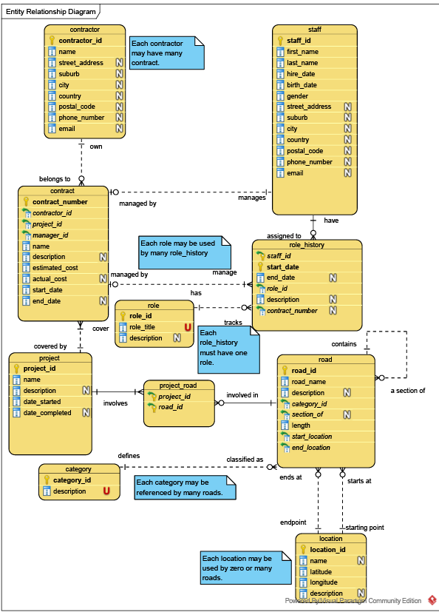
Task 3:
DROP TABLE category CASCADE CONSTRAINTS;
DROP TABLE location CASCADE CONSTRAINTS;
DROP TABLE road CASCADE CONSTRAINTS;
DROP TABLE role CASCADE CONSTRAINTS;
DROP TABLE project CASCADE CONSTRAINTS;
DROP TABLE project_road CASCADE CONSTRAINTS;
DROP TABLE staff CASCADE CONSTRAINTS;
DROP TABLE contractor CASCADE CONSTRAINTS;
DROP TABLE contract CASCADE CONSTRAINTS;
DROP TABLE role_history CASCADE CONSTRAINTS;

CREATE TABLE category (
category_id VARCHAR2(16),
description VARCHAR2(64)
CONSTRAINT category_description_nn NOT NULL,
CONSTRAINT category_pk PRIMARY KEY ( category_id ),
CONSTRAINT category_description_uk UNIQUE ( description )
);
DESCRIBE category;
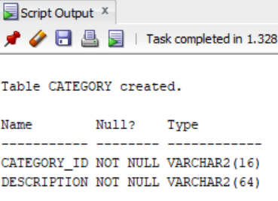

CREATE TABLE location (
location_id VARCHAR2(16),
name VARCHAR2(64),
latitude NUMBER
CONSTRAINT location_latitude_nn NOT NULL,
longitude NUMBER
CONSTRAINT location_longitude_nn NOT NULL,
description VARCHAR2(64),
CONSTRAINT location_pk PRIMARY KEY ( location_id ),
CONSTRAINT location_latitude_longitude_uk UNIQUE ( latitude, longitude )
);
DESCRIBE location;
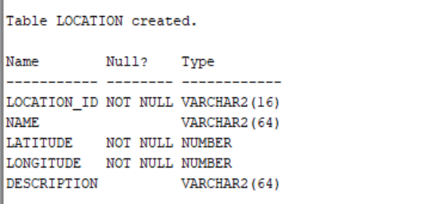

CREATE TABLE road (
road_id VARCHAR2(16),
road_name VARCHAR2(64)
CONSTRAINT road_name_nn NOT NULL,
description VARCHAR2(64),
category_id VARCHAR2(16)
CONSTRAINT road_category_id_nn NOT NULL,
section_of VARCHAR2(16),
length NUMBER(8)
CONSTRAINT road_length_nn NOT NULL,
start_location VARCHAR2(16)
CONSTRAINT road_start_location_nn NOT NULL,
end_location VARCHAR2(16)
CONSTRAINT road_end_location_nn NOT NULL,
CONSTRAINT road_pk PRIMARY KEY ( road_id ),
CONSTRAINT road_category_id_fk FOREIGN KEY ( category_id )
REFERENCES category ( category_id ),
CONSTRAINT road_section_of_fk FOREIGN KEY ( section_of )
REFERENCES road ( road_id ),
CONSTRAINT road_start_location_fk FOREIGN KEY ( start_location )
REFERENCES location ( location_id ),
CONSTRAINT road_end_location_fk FOREIGN KEY ( end_location )
REFERENCES location ( location_id )
);
DESCRIBE road;
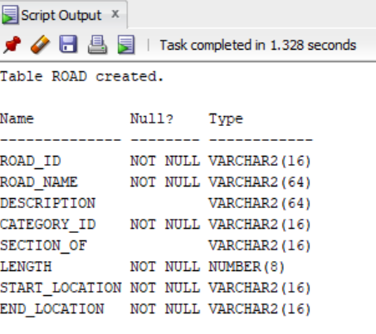

CREATE TABLE role (
role_id VARCHAR2(16),
role_title VARCHAR2(64)
CONSTRAINT role_title_nn NOT NULL,
description VARCHAR2(64),
CONSTRAINT role_pk PRIMARY KEY ( role_id ),
CONSTRAINT role_title_uk UNIQUE ( role_title )
);
DESCRIBE role;
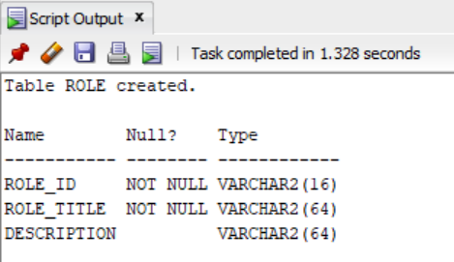

CREATE TABLE project (
project_id VARCHAR2(16),
name VARCHAR2(64)
CONSTRAINT project_name_nn NOT NULL,
description VARCHAR2(64),
date_started DATE
CONSTRAINT project_date_started_nn NOT NULL,
date_completed DATE,
CONSTRAINT project_pk PRIMARY KEY ( project_id )
);
DESCRIBE project;
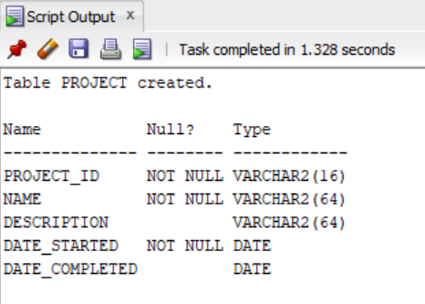

CREATE TABLE project_road (
project_id VARCHAR2(16),
road_id VARCHAR2(16),
CONSTRAINT project_road_pk PRIMARY KEY ( project_id, road_id ),
CONSTRAINT project_road_project_id_fk FOREIGN KEY ( project_id )
REFERENCES project ( project_id ),
CONSTRAINT project_road_road_id_fk FOREIGN KEY ( road_id )
REFERENCES road ( road_id )
);
DESCRIBE project_road;
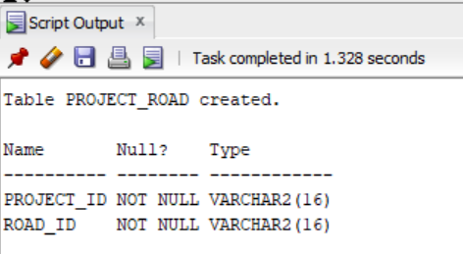

CREATE TABLE staff (
staff_id VARCHAR2(16),
first_name VARCHAR2(16)
CONSTRAINT staff_first_name_nn NOT NULL,
last_name VARCHAR2(16)
CONSTRAINT staff_last_name_nn NOT NULL,
hire_date DATE
CONSTRAINT staff_hire_date_nn NOT NULL,
birth_date DATE
CONSTRAINT staff_birth_date_nn NOT NULL,
gender VARCHAR2(14) DEFAULT 'not known'
CONSTRAINT staff_gender_nn NOT NULL,
street_address VARCHAR2(32),
suburb VARCHAR2(20),
city VARCHAR2(20),
country VARCHAR2(20),
postal_code VARCHAR2(6),
phone_number VARCHAR2(16),
email VARCHAR2(30),
CONSTRAINT staff_pk PRIMARY KEY ( staff_id ) ,
CONSTRAINT staff_gender_ck CHECK (gender IN ('not known', 'male', 'female', 'not applicable')) -- ISO/IEC 5218:2022
);
DESCRIBE staff;
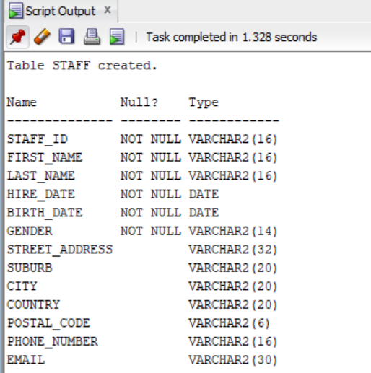

CREATE TABLE contractor (
contractor_id VARCHAR2(16),
name VARCHAR2(64)
CONSTRAINT contractor_name_nn NOT NULL,
street_address VARCHAR2(32),
suburb VARCHAR2(20),
city VARCHAR2(20),
country VARCHAR2(20),
postal_code VARCHAR2(6),
phone_number VARCHAR2(16),
email VARCHAR2(30),
CONSTRAINT contractor_pk PRIMARY KEY ( contractor_id )
);
DESCRIBE contractor;
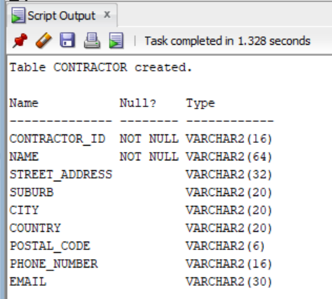

CREATE TABLE contract (
contract_number VARCHAR2(16),
contractor_id VARCHAR2(16)
CONSTRAINT contract_contractor_id_nn NOT NULL,
project_id VARCHAR2(16)
CONSTRAINT contract_project_id_nn NOT NULL,
manager_id VARCHAR2(16)
CONSTRAINT contract_manager_id_nn NOT NULL,
name VARCHAR2(64)
CONSTRAINT contract_name_nn NOT NULL,
description VARCHAR2(64),
estimated_cost NUMBER(16)
CONSTRAINT contract_estimated_cost_nn NOT NULL,
actual_cost NUMBER(16),
start_date DATE
CONSTRAINT contract_start_date_nn NOT NULL,
end_date DATE,
CONSTRAINT contract_pk PRIMARY KEY ( contract_number ),
CONSTRAINT contract_contractor_id_fk FOREIGN KEY ( contractor_id )
REFERENCES contractor ( contractor_id ),
CONSTRAINT contract_manager_id_fk FOREIGN KEY ( manager_id )
REFERENCES staff ( staff_id ),
CONSTRAINT contract_project_id_fk FOREIGN KEY ( project_id )
REFERENCES project ( project_id )
);
DESCRIBE contract;
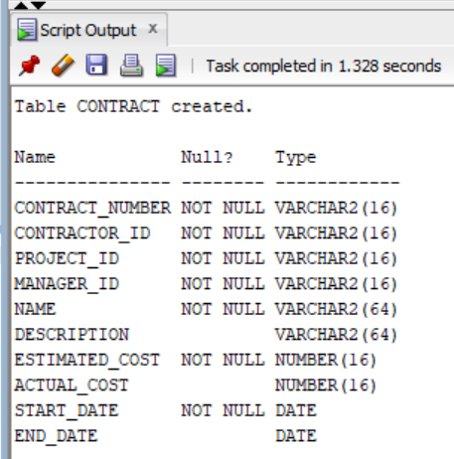

CREATE TABLE role_history (
staff_id VARCHAR2(16),
start_date DATE,
end_date DATE,
role_id VARCHAR2(16)
CONSTRAINT role_history_role_id_nn NOT NULL,
description VARCHAR2(16),
contract_number VARCHAR2(16),
CONSTRAINT role_history_pk PRIMARY KEY ( staff_id,
start_date ),
CONSTRAINT role_history_staff_id_fk FOREIGN KEY ( staff_id )
REFERENCES staff ( staff_id ),
CONSTRAINT role_history_role_id_fk FOREIGN KEY ( role_id )
REFERENCES role ( role_id ),
CONSTRAINT role_history_contract_number_fk FOREIGN KEY ( contract_number )
REFERENCES contract ( contract_number )
);
DESCRIBE role_history;
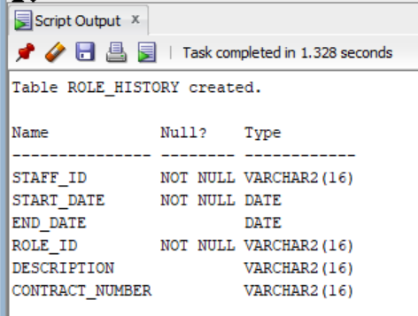

Task 4:
TRUNCATE TABLE role_history;
TRUNCATE TABLE contract;
TRUNCATE TABLE contractor;
TRUNCATE TABLE staff;
TRUNCATE TABLE project_road;
TRUNCATE TABLE project;
TRUNCATE TABLE role;
TRUNCATE TABLE road;
TRUNCATE TABLE location;
TRUNCATE TABLE category;

-- insert category
INSERT INTO category VALUES (
'cat_1', 'National (high volume)'
);

INSERT INTO category VALUES (
'cat_2', 'National'
);

INSERT INTO category VALUES (
'cat_3', 'Regional'
);

INSERT INTO category VALUES (
'cat_4', 'Arterial'
);

INSERT INTO category VALUES (
'cat_5', 'Primary collector'
);

INSERT INTO category VALUES (
'cat_6', 'Secondary collector'
);

INSERT INTO category VALUES (
'cat_7', 'Access'
);

INSERT INTO category VALUES (
'cat_8', 'Access (low-volume)'
);

INSERT INTO category VALUES (
'cat_9', 'Not applicable'
);

-- insert location
INSERT INTO location VALUES (
'loc_1', 'Wellesley, Victoria, Halsey Street', - 36.848251, 174.756382, NULL
);

INSERT INTO location VALUES (
'loc_2', 'Wellesley Street W/E', - 36.850850, 174.764493, NULL
);

INSERT INTO location VALUES (
'loc_3', 'Wellesley Street E', - 36.856020, 174.769727, NULL
);

INSERT INTO location VALUES (
'loc_4', 'Halsey, Jellicoe Street', - 36.841262, 174.758230, NULL
);

INSERT INTO location VALUES (
'loc_5', 'Jellicoe Street', - 36.839688, 174.753947, NULL
);

INSERT INTO location VALUES (
'loc_6', 'Hamer Street', - 36.836883, 174.758216, NULL
);

INSERT INTO location VALUES (
'loc_7', 'Hamer Street', - 36.840344, 174.754917, NULL
);

INSERT INTO location VALUES (
'loc_8', 'Brigham Street', - 36.836883, 174.759736, NULL
);

INSERT INTO location VALUES (
'loc_9', 'Brigham Street', - 36.840638, 174.755966, NULL
);

-- insert road
INSERT INTO road VALUES (
'road_1', 'Wellesley Street', NULL, 'cat_5', NULL, 1500, 'loc_1', 'loc_3'
);

INSERT INTO road VALUES (
'road_2', 'Wellesley Street West', NULL, 'cat_5', 'road_1', 750, 'loc_1', 'loc_2'
);

INSERT INTO road VALUES (
'road_3', 'Wellesley Street East', NULL, 'cat_5', 'road_1', 750, 'loc_2', 'loc_3'
);

INSERT INTO road VALUES (
'road_4', 'Halsey Street', NULL, 'cat_6', NULL, 800, 'loc_1', 'loc_4'
);

INSERT INTO road VALUES (
'road_5', 'Jellicoe Street', NULL, 'cat_6', NULL, 500, 'loc_4', 'loc_5'
);

INSERT INTO road VALUES (
'road_6', 'Hamer Street', NULL, 'cat_6', NULL, 500, 'loc_6', 'loc_7'
);

INSERT INTO road VALUES (
'road_7', 'Brigham Street', NULL, 'cat_6', NULL, 550, 'loc_8', 'loc_9'
);

-- insert role
INSERT INTO role VALUES (
'role_1', 'manager', NULL
);

INSERT INTO role VALUES (
'role_2', 'worker', NULL
);

INSERT INTO role VALUES (
'role_3', 'officer', NULL
);

INSERT INTO role VALUES (
'role_4', 'inspector', NULL
);

INSERT INTO role VALUES (
'role_5', 'equipment operator', NULL
);

-- insert project
INSERT INTO project VALUES (
'pro_1', 'Wellesley St E maintenance', 'long term', '08-oct-2000', NULL
);

INSERT INTO project VALUES (
'pro_2', 'Wellesley St and Halsey St upgrade', 'fix term', '08-oct-2020', '08-oct-2021'
);

INSERT INTO project VALUES (
'pro_3', 'Jellicoe St maintenance', 'long term', '08-oct-2020', NULL
);

INSERT INTO project VALUES (
'pro_4', 'Wellesley St W maintenance', 'long term', '08-oct-2019', NULL
);

INSERT INTO project VALUES (
'pro_5', 'Halsey St maintenance', 'long term', '08-oct-2015', NULL
);

-- insert project_road
INSERT INTO project_road VALUES (
'pro_1', 'road_3'
);

INSERT INTO project_road VALUES (
'pro_2', 'road_1'
);

INSERT INTO project_road VALUES (
'pro_2', 'road_4'
);

INSERT INTO project_road VALUES (
'pro_3', 'road_5'
);

INSERT INTO project_road VALUES (
'pro_4', 'road_2'
);

INSERT INTO project_road VALUES (
'pro_5', 'road_4'
);

-- insert staff
INSERT INTO staff VALUES (
'sta_1', 'Geraint', 'Astghik', '10-oct-2022', '10-oct-1980', 'not applicable', '601 Blockhouse Bay Road', 'Blockhouse Bay', 'Auckland'
, 'New Zealand', '0600', '0227770088', 'geraint@autuni.ac.nz'
);

INSERT INTO staff VALUES (
'sta_2', 'Athena', 'Youssef', '31-jan-2000', '23-sep-1967', 'male', '652 Dominion Road', 'Mount Eden', 'Auckland', 'New Zealand',
'1041', '0214567890', 'athena@a.really.long.email.com'
);

INSERT INTO staff VALUES (
'sta_3', 'Kiara', 'Theodor', '1-jan-2010', '12-aug-1990', 'female', '1010 Beach Road', 'Torbay', 'Auckland', 'New Zealand', '0630'
, '0219877890', 'kiara@x.com'
);

INSERT INTO staff VALUES (
'sta_4', 'Abigail', 'Lennox', '31-jan-1990', '8-jan-1969', 'not known', '324 Blockhouse Bay Road', 'Avondale', 'Auckland', 'New Zealand'
, '0600', '0234567890', 'a@a.com'
);

INSERT INTO staff VALUES (
'sta_5', 'Jumanah', 'Samaha', '31-jan-2018', '13-mar-1985', 'male', '982 Beach Road', 'Torbay', 'Auckland', 'New Zealand', '0630'
, '0294567890', 'jumanah@gmail.com'
);

INSERT INTO staff VALUES (
'sta_6', 'Lee', 'Liao', '31-jan-2020', '23-oct-1990', 'female', '630 Dominion Road', 'Mount Eden', 'Auckland', 'New Zealand', '1041'
, '0214892890', 'lee@autuni.ac.nz'
);

-- insert contractor
INSERT INTO contractor VALUES (
'conor_1', 'Big company', '321 Forest Hill Road', 'Waiatarua', 'Auckland', 'New Zealand', '0612', '+61092851538368', 'contractor@bigcompany.co.au'
);

INSERT INTO contractor VALUES (
'conor_2', 'Small company', '31 McDowall Street', NULL, 'Forest Glen', 'Australia', '4556', '+61092851538368', 'contractor@great.co.au'
);

INSERT INTO contractor VALUES (
'conor_3', 'AUT student company', '432 Don Buck Road', 'Massey', 'Auckland', 'New Zealand', '0614', '025873620', 'contractor@aut.ac.nz'
);

INSERT INTO contractor VALUES (
'conor_4', 'Auckland construct', '928 Beach Road', 'Waiake', 'Auckland', 'New Zealand', '0630', '+61092851538368', 'contractor@great.co.au'
);

INSERT INTO contractor VALUES (
'conor_5', 'NZ build', '130 Adelaide Road', 'Mount Cook', 'Wellington', 'New Zealand', '6021', '0279239875', 'contractor@nz.co.au'
);

--insert contract
INSERT INTO contract VALUES (
'conct_1', 'conor_1', 'pro_1', 'sta_1', 'Big contract', NULL, 97654, 90000, '08-oct-2000', '08-oct-2001'
);

INSERT INTO contract VALUES (
'conct_2', 'conor_2', 'pro_1', 'sta_1', 'Small contract', NULL, 1234, NULL, '08-oct-2001', NULL
);

INSERT INTO contract VALUES (
'conct_3', 'conor_5', 'pro_2', 'sta_3', 'Wellesley St and Halsey St upgrade contract', NULL, 77995, 98756, '08-oct-2020', '08-oct-2021'
);

INSERT INTO contract VALUES (
'conct_4', 'conor_5', 'pro_3', 'sta_4', 'Jellicoe St maintenance contract', NULL, 51265, 43215, '08-oct-2020', '08-oct-2021'
);

INSERT INTO contract VALUES (
'conct_5', 'conor_2', 'pro_3', 'sta_4', 'Jellicoe St maintenance contract', NULL, 25123, NULL, '08-oct-2021', NULL
);

INSERT INTO contract VALUES (
'conct_6', 'conor_3', 'pro_4', 'sta_5', 'Wellesley St W maintenance contract', NULL, 65132, NULL, '08-oct-2019', NULL
);

INSERT INTO contract VALUES (
'conct_7', 'conor_3', 'pro_5', 'sta_6', 'Halsey St maintenance contract', NULL, 85612, NULL, '08-oct-2015', NULL
);

-- insert role_history
INSERT INTO role_history VALUES (
'sta_1', '10-oct-2000', '10-dec-2000', 'role_2', 'promotion', 'conct_1'
);

INSERT INTO role_history VALUES (
'sta_1', '10-dec-2000', '08-oct-2001', 'role_1', 'contract ends', 'conct_1'
);

INSERT INTO role_history VALUES (
'sta_1', '08-oct-2001', NULL, 'role_1', NULL, 'conct_2'
);

INSERT INTO role_history VALUES (
'sta_2', '08-oct-2000', '10-dec-2000', 'role_1', 'promotion', 'conct_1'
);

INSERT INTO role_history VALUES (
'sta_2', '10-dec-2000', '08-oct-2001', 'role_3', 'contract ends', 'conct_1'
);

INSERT INTO role_history VALUES (
'sta_2', '08-oct-2001', NULL, 'role_3', NULL, 'conct_2'
);

INSERT INTO role_history VALUES (
'sta_3', '08-oct-2020', '08-oct-2021', 'role_1', 'contract ends', 'conct_3'
);

INSERT INTO role_history VALUES (
'sta_3', '08-oct-2021', NULL, 'role_1', NULL, 'conct_7'
);

INSERT INTO role_history VALUES (
'sta_4', '08-oct-2020', '08-oct-2021', 'role_1', 'contract ends', 'conct_4'
);

INSERT INTO role_history VALUES (
'sta_4', '08-oct-2021', NULL, 'role_1', NULL, 'conct_5'
);

INSERT INTO role_history VALUES (
'sta_5', '08-oct-2019', NULL, 'role_1', NULL, 'conct_6'
);

INSERT INTO role_history VALUES (
'sta_6', '08-oct-2015', '08-oct-2021', 'role_1', 'promotion', 'conct_7'
);

INSERT INTO role_history VALUES (
'sta_6', '08-oct-2021', NULL, 'role_3', NULL, 'conct_7'
);

COMMIT;

-- Evidence of Sample data
SELECT table_name FROM user_tables;
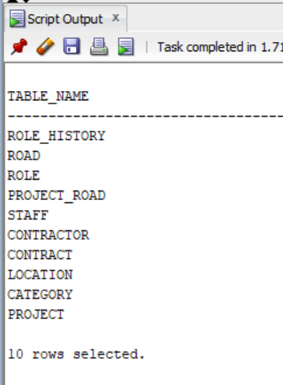

SELECT * FROM category;
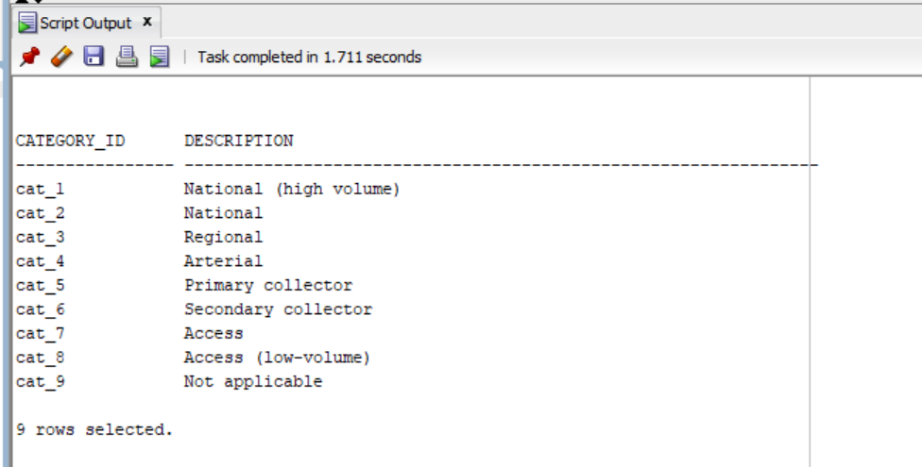

SELECT * FROM location;
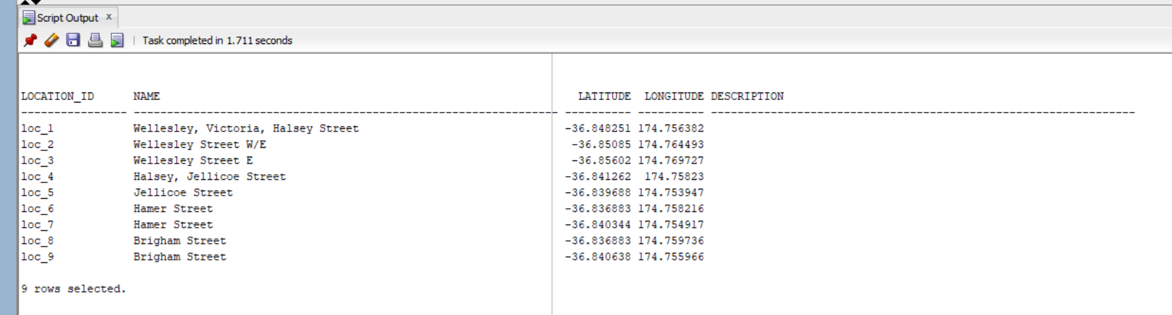

SELECT * FROM road;
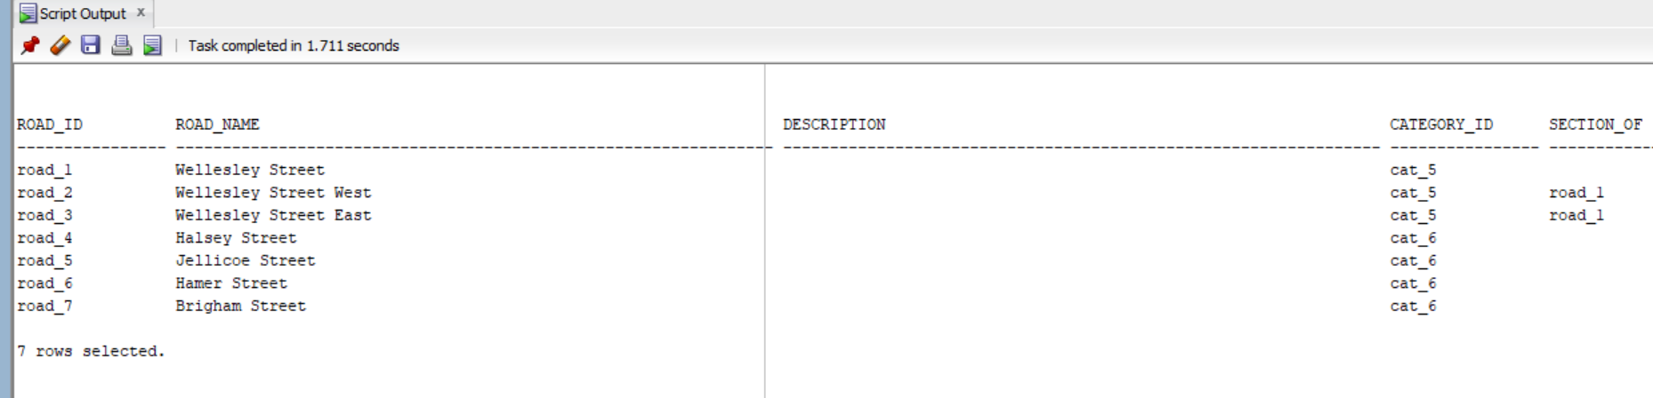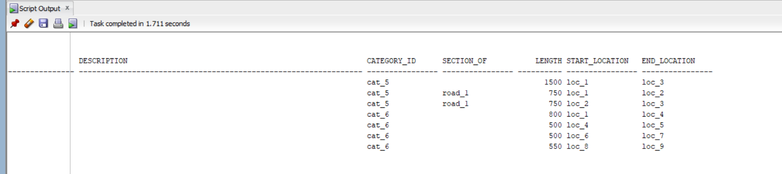

SELECT * FROM role;
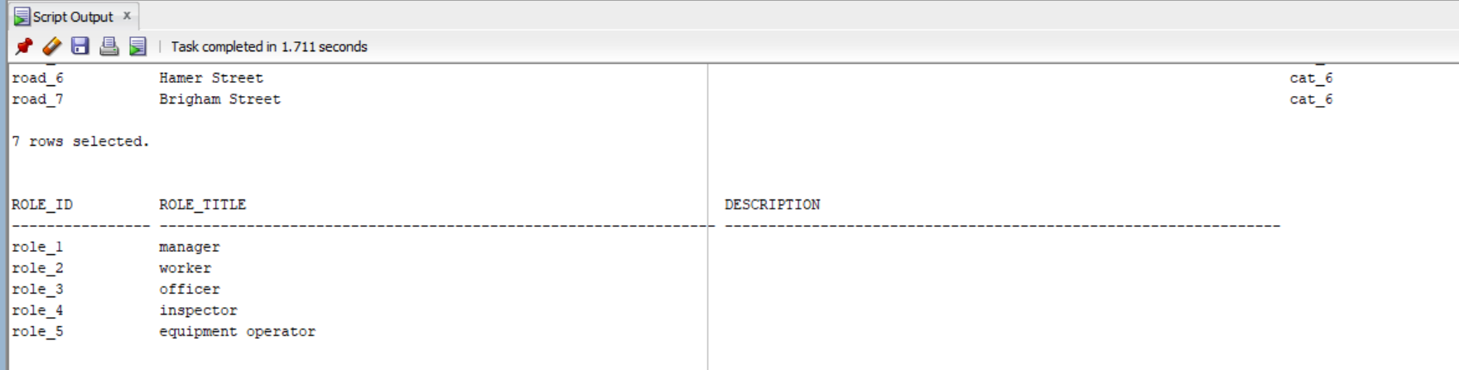

SELECT * FROM project;
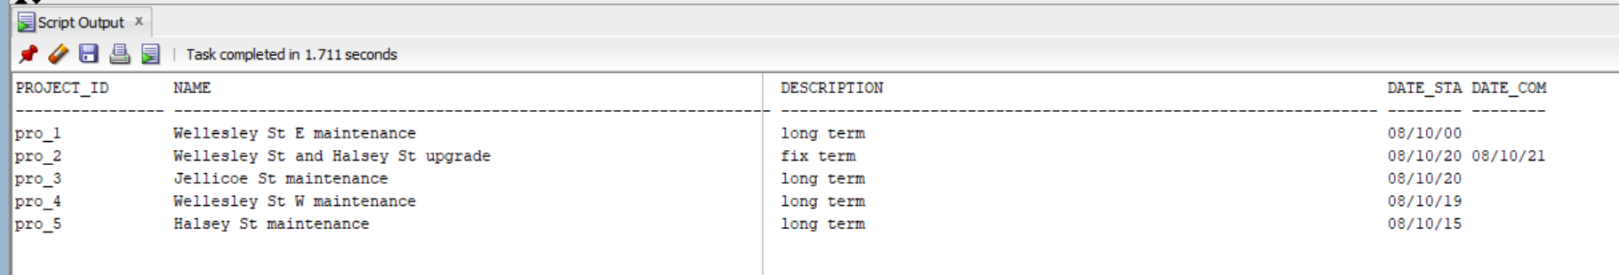

SELECT * FROM project_road;
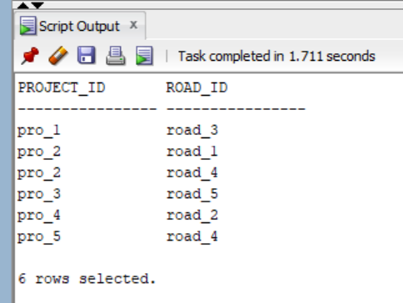

SELECT * FROM staff;
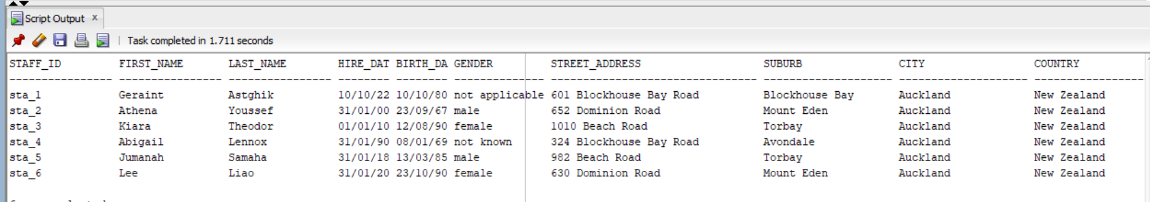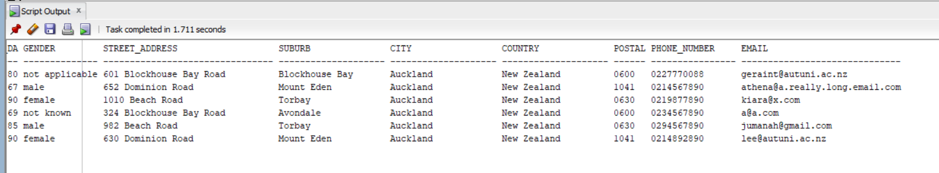

SELECT * FROM role_history;
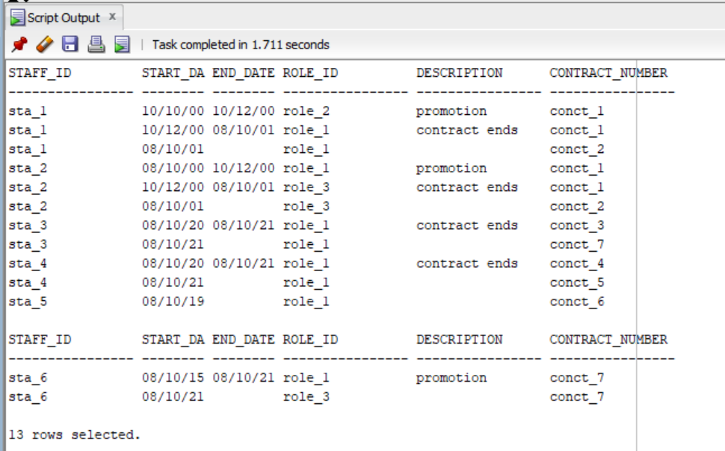

SELECT * FROM contractor;
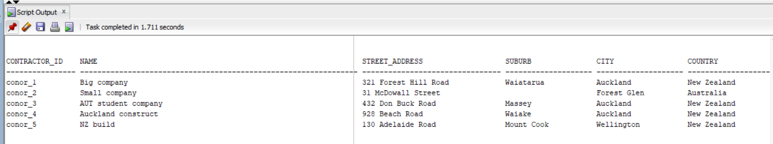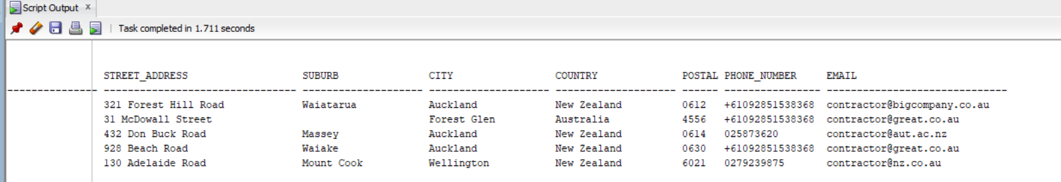

SELECT * FROM contract;
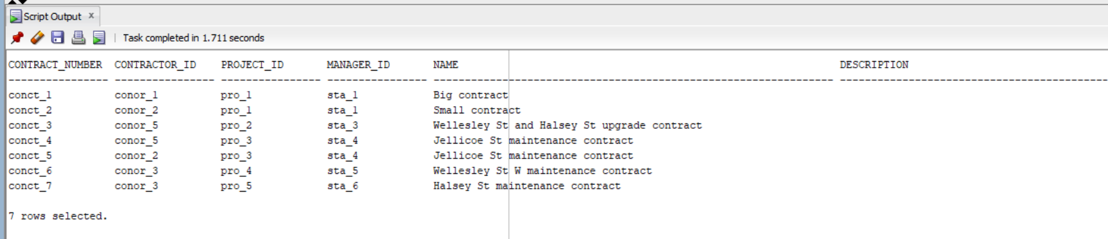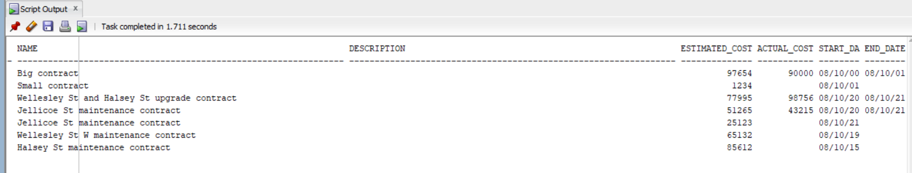

Task 5:
1.
Purpose of the query:
To search for staff's role history.
Retrieve staff ID, Staff name (Concatenation of Last and First names), the Start date for the role, the End date for the role, Role ID, Description for the role history, and Contract number.

SQL SELECT query:
SELECT
s.staff_id,
s.first_name
|| ' '
|| s.last_name AS "Full name",
r.start_date,
r.end_date,
r.role_id,
r.description,
r.contract_number
FROM
staff s,
role_history r
WHERE
s.staff_id = r.staff_id
AND lower(s.staff_id) = lower('&staff_id')
ORDER BY
start_date ASC;

Output/Result of the query:
Input for staff_id = “Sta_1”
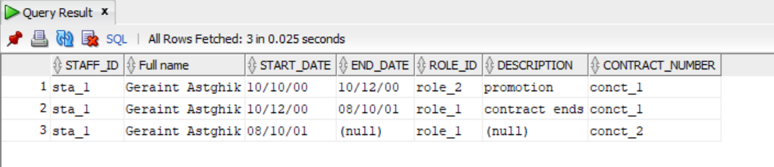

2.
Purpose of the query:
To search for all roads that have at least one subsection.
Retrieve Road ID and Road name for the main road, and Road ID and Road name for the subsection.

SQL SELECT query:
SELECT
r.road_id AS "Road ID",
r.road_name AS "Road name",
s.road_id AS "Subsection ID",
s.road_name AS "Subsection name"
FROM
road r,
road s
WHERE
r.road_id = s.section_of
ORDER BY
r.road_id ASC;

Output/Result of the query:
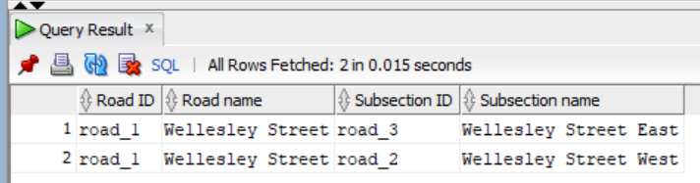

3.
Purpose of the query:
To search for total number, total length, average length, minimum length, and maximum length for each types of road, which its average length is greater that a value that user has entered.
Retrieve Category ID, Category description, Total number, Total length, Average length, Minimum length, and Maximum length.

SQL SELECT query:
SELECT
c.category_id AS "Category ID",
c.description AS "Road category",
COUNT(*) AS "Number of roads",
SUM(length) AS "Total length",
AVG(length) AS "Average length",
MIN(length) AS "Minimum length",
MAX(length) AS "Maximum length"
FROM
road r,
category c
WHERE
r.category_id = c.category_id
GROUP BY
c.category_id,
c.description
HAVING
AVG(length) > &avg_length
ORDER BY
c.category_id ASC;

Output/Result of the query:
Input for avg_length = 680
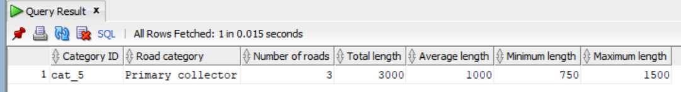
Input for avg_length = 500
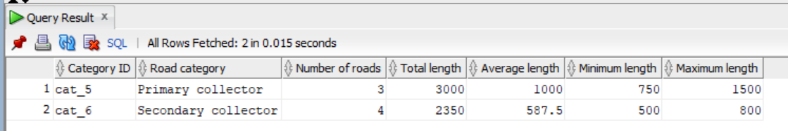

4.
Purpose of the query:
To search all staff that has been worked on the project that user has entered.
Retrieve Staff ID, Staff name (Concatenation of Last and First names), Contract number, the Start date for the role, the End date for the role, Duration, staff’s Phone number, staff’s Email. If end date is null, use sysdate for duration calculation.

SQL SELECT query:
SELECT
s.staff_id AS "Staff ID",
s.first_name
|| ' '
|| s.last_name AS "Full name",
r.contract_number,
r.start_date,
r.end_date,
trunc(nvl(r.end_date, sysdate) - r.start_date) AS "Duration",
s.phone_number AS "Phone number",
s.email AS "Email"
FROM
project p,
contract c,
role_history r,
staff s
WHERE
( p.project_id = c.project_id
AND c.contract_number = r.contract_number
AND r.staff_id = s.staff_id )
AND ( lower(p.project_id) = lower('&project_id') )
ORDER BY
r.start_date ASC,
s.staff_id ASC;

Output/Result of the query:
Input for project_id = “Pro_1”
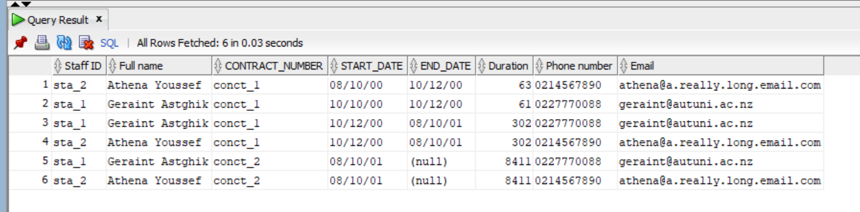

5.
Purpose of the query:
To search all contractor and its associated contract. This query includes all contractor that may or may not have contracts.
Retrieve Contractor ID, Contractor name, Contract number, Project ID, Contract name, Estimated cost, Actual cost, Cost difference, the Start date for the contract, the End date for the contract, the Duration for the contract. If end date is null, use sysdate for duration calculation.

SQL SELECT query:
SELECT
o.contractor_id,
o.name AS "Contractor name",
c.contract_number,
c.project_id,
c.name AS "Contract name",
c.estimated_cost,
c.actual_cost,
c.actual_cost - c.estimated_cost AS "Cost difference",
c.start_date,
c.end_date,
trunc(nvl(c.end_date, sysdate) - c.start_date) AS "Duration"
FROM
contractor o,
contract c
WHERE
o.contractor_id = c.contractor_id (+)
ORDER BY
o.contractor_id ASC,
c.contract_number ASC;

Output/Result of the query:
